Student Assessment Submission and Declaration
When submitting evidence for assessment, each student must sign a declaration confirming that the work is their own.
Student name: ADEL SHURAB /21023153 |  | Assessor name:Jumana Khwaileh
Issue date:  20-8-2022 | Submission date:  17-9-2022 |  | Submitted on:  15-9-2022
Program:Higher National Diploma in artificial intelligence
Unit: 5 Security
Assignment number and title:Assignment 1– Organizational Security Management

PUT your Answer here

TASK A Security Analysis and Risk Assessment

Q1 . the different security risks that companies may face
1- MITM: A man in the middle attack occurs when a attacker inserts himself into a communication among a user and a program. It may be used to spy or mimic one of the individuals, making it look as though everything is normal.
2- Identity theft :This happens when anyone steals your personal data or info, such as your ID number, bank account number, or Your medical information.
3-Malware:any file or code, generally supplied across a network, that infects, investigates, steals, or performs nearly any action desired by the attacker
4-Phishing Attack: Phishing occurs when hackers send malicious emails with the intent of duping individuals towards falling for a scam.
5- Receiving incomplete or confusing information/data.
6- wrong contact with the branch and the main building by connecting to the wrong company or the wrong IP.

A . Unauthorized Use Of A System:

when a person gains entry to a computer network, system, application software, data, or other resources without permission

Examples of these types of unauthorized activities include but are not limited to: Obtaining, using, or attempting to use someone else's password. Viewing, copying, transferring, modifying or making public the files, printouts or computer processes of another user unless you have their oral or written permission

1-Someone (hacker) can snoop on confidential information

2- Software must be used by trusted and authorized persons

3- A hacker can read or copy data, but not destroy it

4- Reading data can destroy a company even if it doesn't destroy the data

5- When personal information is obtained, identity theft and identity theft can be obtained

B . Unauthorized Removal Or Copying Of Data Or Code From A System :

It's called data theft What is data theft? It is simply the unauthorized copying or removal of confidential information from an institution or company. Theft is such as stealing customer records or company information or even intellectual property theft.

Through this we conclude:

1 . A person may transfer information to another unauthorized person, and this is data theft

2 . Theft of product data or theft of sensitive company data

3 . If the data falls into the wrong hands, such as the company's competitors, the company will lose the sense of competition that the company was maintaining

4 . The worst case scenario is to completely remove the data

c - Damage to or destruction of physical system assets and environment:

Measures taken to protect systems, buildings and related supporting infrastructure from threats associated with their physical environment. If they are destroyed, this is what happens:

1 . Someone may damage the hardware in the ICT system. A hard disk holds a lot of data. If the disk was sabotaged, the data would become inaccessible

2 . The hardware in an ICT system can be worth many hundreds of thousands of pounds

3 . If any of it is damaged or stolen then it will take time to replace it.

4 . The cost of replacement is usually covered by insurance, so the main problem is the time delay in installing replacement equipment.

d- damage to or destruction of data or code inside or outside the system :

1 . This delay can result in lost business and, as a consequence, the organisation may lose money

2 . Consequential loss may not be covered by insurance, so this is a ‘real’ loss.

3 . Damage to data or code Data or software should only be altered or deleted by someone who is authorised to do so

4 . A hacker may damage – i.e. amend or delete – the data or software

e - Naturally occurring risks :

These are the normal errors that occur due to:

1 . Human actions : Human error, employee that disregards policy

2 . Systems issues : Out of date or incorrectly configured/installed anti virus and firewall, confusion over backup policy could result in accidental overwrite, poor group policy configuration, incorrect user access levels.

2 . organizational security measures they must follow to protect their systems.
1- Business continuance :In the case of a data breach, a risk assessment should be performed, and a contingency plan should be developed. Backup, external storage, data recovery methods, and access to fast hardware replacement should all be included in this contingency plan. It should include insurance for replacement, company loss, and all rehab work.
2- Backup/restoration of data: Rather of waiting for calamity to hit, the goal should be to prepare ahead so that the entire system can always be fully operational again within a specific time frame in the case of a power outage or other catastrophic occurrence. Employees in charge of data recovery, and also their managers, should be aware of the processes to be followed. The contingency plan must be established based on a thorough risk assessment, so every possibility is considered.
3- Audits: A security audit must be performed to determine what may go wrong and to prepare fixes before a attacker – or another individual – exploits the problem. An organization that is ignorant of where and how security breaches occur may find itself in an expensive and embarrassing scenario. Audits might involve review and management. Personal, business, and technological trust must be established and reviewed.

4- API Security Testing:Security testing assists developers in identifying and remediating vulnerabilities in APIs and online services. APIs may be protected from illegal/unauthorized access and exploitation by extensively testing them on a regular basis. An API must be validated to provide robust authentication of customer requests, SSL/TLS encryption of any and all communication, and user input sanitization

Q2 : method for assessing and addressing security risks in the organization:

Establish a risk management framework

2. Analyze risks

3. Evaluate risks

4. Select risk treatment options

5. Identify risks:

Risk management : is essential for all businesses, even small and medium-sized ones (SMPs). This pertains to safeguarding the business's resources, finances, and operations as well as assisting in good corporate governance, legal compliance, and due diligence. Effective risk management will safeguard the company's standing, integrity, and reputation. Establishing a risk management "culture" within the company is crucial. This highlights how crucial it is for all staff members to include risk management into their regular tasks. The objective of developing a risk management culture is to establish an environment where partners and staff naturally seek for risks and take their effects into account when making wise operational decisions.
Implementing a risk management program provides many benefits, including:
- More effective strategic planning;
- Better cost control through enhanced workflows, client evaluation and engagement processes;
- Increased profitability through better client and job controls;
- Reduced risks of litigation as a consequence of processes and contingency plans;
- Increased knowledge and understanding of exposure to risk;
- A systematic, well-informed and thorough method of decision-making;
- Less disruption and less rework through better understanding of process by all staff in the firm; and
- Setting the scene for continual improvement within the firm.

I chose to explain this method and its statements

The risk analysis process is the center point of risk management; it is a systematic use of information to investigate, estimate and evaluate risk. Essentially risk analysis is about the estimation of unseen and probabilistic events. The probabilities are unknown and the risk analysis is used to estimate the probability of occurrence . The tools used here can also vary from organization to organization depending on their strategies, objectives and goals. In order to analyze the risk the characteristics of risks must be adequately documented. Risk analysis involves the systematic use of information to identify sources, estimate consequences and the likelihood of occurrence of these risks risk. Risk identification aims to determine the possible causes and probable consequence of the risk therefore it is imperative to measure the magnitude of the potential loss, and the probability that the loss will occur. Here the acceptability of the risk is determined and the actions that can be taken to make the risk more acceptable are evaluated . According to Sun et al. the purpose of risk evaluation is to prioritize risks in terms of severity and level of influence. Strengths, weaknesses, opportunities and threats (SWOT) analyses are used in many companies as part of the risk analysis phase. Risk Analysis Tables are simple but effective tools to enable this process . Probabilistic Risk Assessment has emerged as an increasingly popular analysis tool in recent years. It is a comprehensive methodology used to evaluate risks associated with large complex operations or products. It adopts a life cycle approach to analysis. Here phases or aspects such from concept definition, through design and manufacture to end of life stages in development are analyzed. It is used to estimate risk by computing real numbers to determine what can go wrong, how likely is it to happen, and what are its consequences. Multiple Criteria Decision Making Analysis techniques use predefined criteria and associated weighting for each criteria to help decision makers systematically assess a risk.

Q3 : physical and virtual security measure :
1 . Redundant array of inexpensive disks (RAID)
Different RAID levels are used to provide hard disk fault tolerance. Each RAID level provides varying levels of data security and performance. The optimal RAID level for a particular circumstance is determined by the significance of the data, its difficulty of replacing that data, as well as the costs related of a respective RAID implementation. The expenses of loss of data and replacement frequently surpass the price of installing a powerful RAID fault tolerance system. RAID can be implemented using dedicated hardware, that is more expensive, or it can be implemented using software. RAID compatibility is included into today's network OSs, like Windows server and UNIX solutions.
Starting with RAID 0
Despite its RAID designation, RAID 0 don't provide any fault tolerance.
RAID 0 may be less fault-tolerant than keeping all of your data on a single hard drive.
RAID 0 merges idle disk space from 2 or many hard drives into the single logical volume, with data copied to equal-sized stripes across all disks.
Read & write are executed simultaneously throughout all drives when using multiple disks.
This implies that disk access is quicker, making RAID 0 performance superior to conventional RAID options and much superior than a single hard drive. 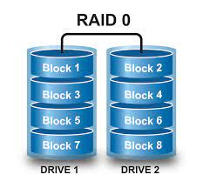
RAID 1
To offer fault tolerance, it requires two hard drives and use disk mirroring.When data is written to one hard drive, it is automatically & concurrently written to the other.Both hard drives in the mirrored setup utilize the same hard disk controller, so hard disk partitions must be around the size to establish the mirror. So if the primary disk fails in the mirrored setup, the second mirrored disk will hold all of the essential information, with no disturbance to data availability. RAID 1 guarantees that now the server continues to operate even if the primary drive fails.
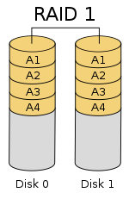
RAID 5
Disk striping with parity, also known as distributed parity, employs distributed parity to write data throughout all disks in an array. In contrast to RAID 0, RAID 5 striping contains parity information, which enables fault tolerance. If a failure occurs, the parity information can be used to recreate the data. And it needs a minimum of 3 disks, with the parity information stored on the equivalent of the single drive. This implies that if you do have three 1TB hard drives, you will have 2TB of storage capacity, with the remaining 1TB being utilized for parity. To expand storage capacity in a RAID 5 array, just add extra disk to the array. RAID 5 could continue to work even if a single disk fails. If one of the array's hard disks fails, the parity will recreate the incomplete information and continue to work with the other drives. RAID 5 read performance outperforms a single drive.
As seen in the diagram below, the parity data are distributed over all drives rather than being written to a single disk. If one of the other data blocks' data is no longer available, the computer could recalculate it using the parity data.
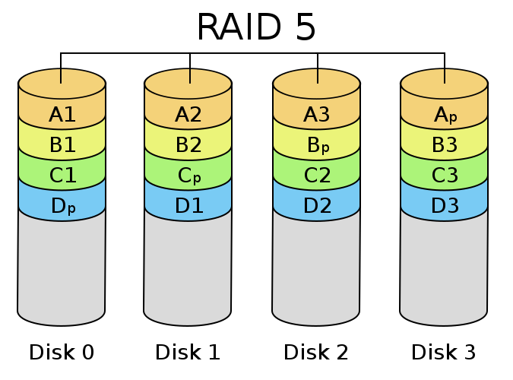
RAID 10
Combines RAID levels 0 & 1, this setup necessitates the use of four disks. A mirrored stripe set is used in the arrangement. RAID 10 leverages the throughput of a stripe set while providing the fault tolerance of the mirrored system. However, in addition to the features of each, RAID 10 inherited the drawbacks of each technique. The downsides in this scenario include significant overhead and lower write performance.
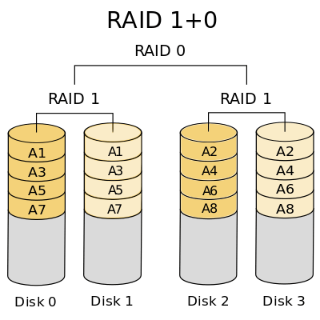

2 . Protection of the backups: It is also one of the important assets of any organization which is meant for disaster recovery.so,while maintaining the backup of stored data it should be properly taken care of that backups should not be kept together in the server room. It should be properly locked and kept in a safe place generally offsite to ensure that they are properly secured and protected in that offsite location. Moreover, when users are working in networking devices care must be taken on the privileges granted to each user and monitored so that without proper permission backups cannot be taken by anyone. 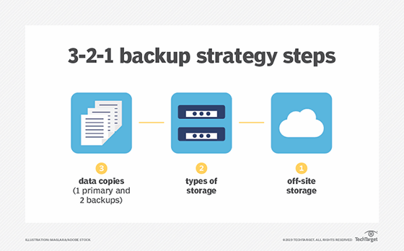

3 . Proper network connection validation: Because virtual security is based on real-time systems, there should be proper source address validation on packets to prevent spoofing, in which every packet in the IT network originates in a subnet and the address of each subnet member is assigned from a range of addresses. It should be the gateway device's job to examine the source address of the packet to confirm that it is inside the subnet range, which considerably decreases the chances of intruder access via spoofing.

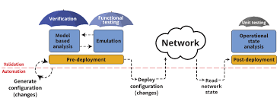

TASK B Solution Selection

Q4

Firewall : A firewall is a type of network security device that keeps track of incoming and outgoing network traffic and makes decisions about which traffic to allow or deny in accordance with a set of security rules.For more than 25 years, firewalls have served as the first line of defense in network security. They create a barrier separating trustworthy internal secured and controlled networks from shady external networks like the Internet .Hardware, software, software-as-a-service (SaaS), public cloud, or private cloud can all be used as firewalls (virtual).and A firewall can be defined as a program or device that protects a computer while it is connected to the Internet from dangers. The firewall checks all information and data from the Internet, or from any other network .The process of scanning and protection is done by allowing data and information to pass and enter the computer if it is compatible with the firewall settings, or to exclude and expel it if it is malicious software, such as: viruses and spyware, or if it is not compatible with the firewall settings. Protection is a boundary between a computer and the Internet, and it is similar to checkpoints or border posts, which check all those entering the country.
What is the importance of a firewall?
1 . The use of a firewall prevents the leakage of computer user information, and information leakage is one of the biggest risks of using the Internet, as bank accounts or e-mail access can be stolen, and the firewall can detect and immediately block any unsafe entry attempts.
2 . The use of a firewall saves the potential costs of computer maintenance that the user may need because his computer has been compromised.
3 . The firewall usually protects users from any inappropriate or immoral content, as hackers usually target these sites by spreading malicious software, where the firewall can distinguish and block unsafe sites and prevent access to them.

4 . Firewalls protect Internet-connected computers from remote video games, as online video games are one of the most important developments in the history of video games, but they are a potential security risk, as many malicious programs are spread that primarily target fans of these games, Whereas, the firewall blocks any attempts to penetrate the computer system from these sites.
5 . A firewall protects a computer from unauthorized access by others, which means penetration of the device, which exposes it to the theft of important information and data or disrupting the work of the device.

third-party: A third-party service provider is generally regarded as an outside individual or business that executes a contract by offering a service or technology. A third-party service provider in the IT industry often offers a technology that improves an organization's operational efficiency by storing, processing, and/or transmitting data.

Today, third parties are frequently the preferred route for cyber attacks. Attackers breach supply-chain connections and covertly infect their systems and equipment. After then, the attacker use the third party as a "platform" to attack targets with larger value.

Why do you need third-party service providers?

Building a company's own version of an established technology becomes a financial and operational burden because most businesses concentrate on their main product. A excellent example is the decision to use public cloud services rather than creating a private cloud.
When an organization chooses to build a private cloud, it needs to consider the following costs:
- Hardware costs: the number of servers you need to purchase
- Maintenance costs: the time the IT department will spend keeping it functional and updated
- Capacity: the amount of current and future resources you need to optimize the use and cost
- Compute power: the amount of power necessary to meet current needs and additional power for high-use periods
- Access: the ability for off-site users to access remotely

It might be challenging for many businesses to estimate these expenditures. Even if they make accurate estimates, it might be challenging to quantify the operational expenses associated with creating a private cloud.
Third-party service providers allow companies to focus on their primary business operations while giving them a way to remain competitive by reducing operational costs.

Third Party Risks:

The possibility that your company will suffer a negative event (such as a data breach, operational interruption, or reputational damage) when you choose to outsource specific services or utilize software created by third parties to complete specific tasks is known as third-party risk. Any independent company or person that offers software, tangible commodities, supplies, or services is considered a third party. Software suppliers, employment firms, consultants, and contractors are examples of third parties.

Q5 :

DMZ: DMZ is a third type, the inner domain is in a middle plane in parentheses... nor is it explicitly exposed as the web is.The DMZ issue is resolved when the state in the external network needs to be returned to some local service, web server or FTP. These services are placed within an external network in the internal network. The possibility of obtaining services available abroad.

The image below shows more about the definition of DMZ and how it works to protect the internal network: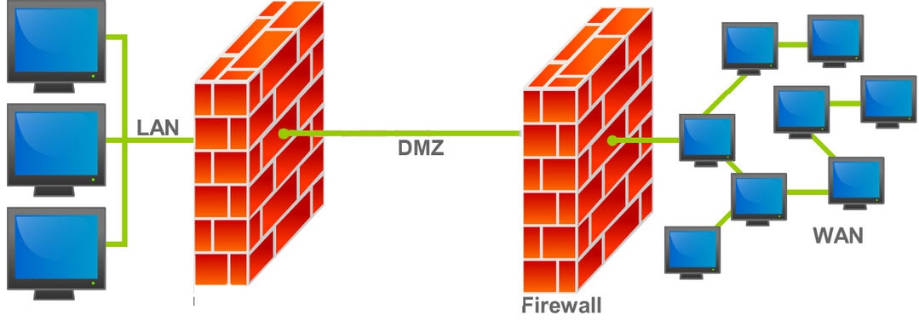

In the event that a service is hacked in the DMZ, then this attacker or hacker only has access to information in the same area that was accessed and has no access to other computers in the internal network LAN, which is one of the best features of DMZ.

The function of dmz in the network: The computer network is one of the most vulnerable types of networks, especially those that provide services to users outside the local network, such as e-mail, network addressing system servers and Internet protocols (DNS). Because of this, dmz is activated in a specific subnet in order to protect the rest of the networks because if the hacker succeeds in attacking one network, he will not be able to reach another.

Conclusion DMZ protects your internal network better so that no one outside your network can access it.

The (DMZ) is a crucial firewall-related idea, and a perimeter network is another term for it. Additionally, DMZ is a component of a network where you set up servers that must be reachable from both within and outside your network. not directly attached to any network, thus access is always required via the firewall. Because it designates an area with little to no enforcement or policing, the military term "DMZ" is employed. Your firewall configuration gains an additional degree of complexity, protection, and flexibility when DMZs are used.

You can add a step that makes it more challenging for an attacker to access the internal network by employing a DMZ. In the case shown above, a hacker attempting to access the internal network through Interface 1 would first need to spoof a request from the web server or proxy server into Interface 2. A DMZ makes it difficult for an intruder to access the inside network, however it is not impossible.Building a DMZ network only requires the addition of the DMZ's third interface. Then, any hosts that can be contacted directly from the internet or require regular external communication are connected using the DMZ interface.

The DMZ network serves as a partition between an organization's internal network and the world wide web. It is isolated using a security gateway, such a firewall, that manages traffic between the DMZ and LAN. Another gateway is used to filter incoming traffic from external networks and secure the default DMZ server. The best location is between the two firewalls. Thanks to the DMZ firewall configuration, incoming network packets are protected by a firewall or other security technologies before they reach the servers situated in the DMZ. Thus, even if an attacker succeeds in getting beyond the first firewall, they still require access to the secured services in the DMZ in order to cause a corporation significant harm.

For both small enterprises and huge corporations, DMZs are an essential part of network security. They raise the level of security on the computer network by outlawing external access to internal servers and data, which can be very detrimental if compromised. Before reaching the servers located in the DMZ, incoming network packets are ensured by the DMZ firewall configuration to be examined by a firewall or other security measures. The ideal placement is in between two firewalls. Thus, even if a competent attacker is able to get past the primary firewall, they must first gain access to the hardened services of the DMZ before they can harm a business. A NAT selects the internal network and the external network as its two local networks gateways. Typically, IP addresses assigned to systems on the internal network cannot be relayed to other networks. A few externally legitimate IP addresses have been issued to the gateway. The gateway makes outgoing traffic appear to be coming from one of the valid external addresses while actually being from an internal system. It diverts incoming traffic. traffic to the proper internal system that is meant for a valid external address. After successfully breaching the external firewall and infecting a system in the DMZ, an attacker must first get past an internal firewall in order to access crucial company data. Resources inside a secure DMZ should emit alarms that provide adequate notice before a breach occurs. One might very easily be broken by a highly talented bad guy.

STATIC IP :

A computer's static IP address is a 32-bit value that serves as its internet address. Usually, an internet service provider will supply this number, which looks like a dotted quad (ISP). A computer's static IP address is a 32-bit value that serves as its internet address. Usually, an internet service provider will supply this number, which looks like a dotted quad (ISP).An internet-connected device's IP address, or "internet protocol address," serves as a special identification number. Similar to how individuals use phone numbers to locate and communicate with one another on the phone, computers use IP addresses to locate and communicate with one another online. An IP address might reveal details about the hosting company and location information.As an illustration, when a user tries to access WhatIs.com, their computer queries a domain name system (DNS) server, which is comparable to a telephone information operator, for the right dotted quad number. An IP address is required to uniquely identify a device with a network protocol, and the DNS maps the domain name to the IP address. Your computer utilizes the response it receives to connect to the WhatIs.com server in this scenario. The DNS server links the quad number, which is similar to a phone number.

What are the advantages of Static IP?

The most important features that it has is the high speed of surfing the Internet, because all the sites and services you browse through save cookies on your computer in order to identify you, because your IP address is fixed. When you open the site again, you will not need to set cookies and this It makes the site load fast because the browser cookies are on your device and this is the opposite of the Dynamic IP, as the Dynamic IP must put the new cookie every time you restart the router and since this IP does not change, this makes the sites and servers prefer to use it, it is It is difficult to always change a site address, and when visitors want to enter the site, they wait for the new IP, and for this reason, companies, servers, and others use Static IP.

What are the disadvantages of Static IP?

One of the disadvantages of this type is that it is vulnerable to hacking because when you know your fixed address, any website can publish a malicious link to your computer, or it is possible that anyone professional in hacking can access your device, and this is unlike Dynamic IP. Your IP will be changed and the problem will be resolved.

How static IP work?

If a person or organization wants a static IP address, they must first call their ISP and ask them to provide their device — such as a router, for example — a static IP address. Static IP addresses are not often offered by most ISP firms by default. They will need to restart their device once it is configured with a new, permanent IP address. The same IP address will be used by computers and other hardware behind the router. Once the IP address is set up, it doesn't need to be managed because it stays the same.

However, because there is a cap on the number of static IP addresses that can be requested, paying for a static IP address is frequently necessary. A solution to this problem is IPv6. Static IP addresses are now much simpler and less expensive to acquire and maintain thanks to IPv6, which lengthens IP addresses from 32 bits to 128 bits (16 bytes) and greatly increases the number of available IP addresses. Today, a sizable amount of internet traffic still utilizes IPv4, but more and more of it is switching to IPv6, so both are in use.

Up to 340 undecillion different IP addresses can be used using IPv6. To put it into perspective, there are currently 340 trillion, trillion, trillion distinct IP addresses that may be assigned, which is 340 followed by a total of 36 zeros. This increase in the total number of IP addresses enables significant future expansion of the internet and alleviates what was anticipated to be a future shortage of network addresses.

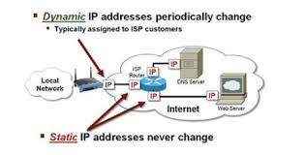

NAT : NAT is an acronym for Network Address Translation, and the simplest definition is the conversion from one IP address to another. It runs on Gateways, such as routers, firewalls, or proxy devices. One of the most common uses of NAT is through ADSL lines with the aim of enabling a group of users within the internal network who have private IP addresses to access the Internet using a single public IP address.

How Does NAT Work?
When computers and servers within a network communicate, they need to be identified to each other by a unique address, in which resulted in the creation of a 32 bit number, and the combinations of these 32 bits would accommodate for over 4 billion unique addresses, known as IP address. This was named IPv4, and although over 4 billion addresses sounds a lot, it really is not considering how fast the world of computers and the internet has grown.
To circumvent this problem, a temporary solution was produced known as NAT. NAT resulted in two types of IP addresses, public and private. A range of private addresses were introduced, which anyone could use, as long as these were kept private within the network and not routed on the internet. The range of private addresses known as RFC 1918 are;
Class A 10.0.0.0 - 10.255.255.255
Class B 172.16.0.0 - 172.31.255.255
Class C 192.168.0.0 - 192.168.255.255
NAT allows you to use these private IP address on the internal network. So within your private network you would assign a unique IP address to all your computers, servers and other IP driven resources, usually done via DHCP. Another company can use the same private IP addresses as well, as long as they are kept internal to their network. So two companies maybe using the same range of IP addresses but because they are private to their network, they are not conflicting with each other.
However when internal hosts do need to communicate to the public network (Internet) then this is where a public address comes into the equation. This address usually purchased from an ISP is a routable public address everyone can see, which would represent your network gateway. This public address would be unique, no one else would use this address.
Now getting to the point; When a host on the internal network with an internal IP address does need to communicate outside it's private network, it would use the public IP address on the network's gateway to identify itself to the rest of the world, and this translation of converting a private IP address to public is done by NAT. For example a computer on an internal address of 192.168.1.10 wanted to communicate with a web server somewhere on the internet, NAT would translate the address 192.168.1.10 to the company's public address, lets call this 1.1.1.1 for example. so that the internal address is identified as the public address when communicating with the outside world. This has to be done because when the web server somewhere on the internet was to reply to this internal computer, it needs to send this to a unique and routable address on the internet, the public address. It can not use the original address of 192.168.1.10, as this is private, none routable and hidden from the outside world. This address, of 1.1.1.1 would be the address of the public address for that company and can be seen by everyone. Now the web server would reply to that public address, 1.1.1.1. NAT would then use its records to translate the packets received from the web server that was destined to 1.1.1.1 back to the internal network address of 192.168.1.10, and though the computer who requested the original info, will receive the requested packets.
Now you can obviously see the two benefits of NAT. Firstly it would save on the IP addresses we use, as every single computer does not need a public address, and also it would hide these private computers from the outside world. Everyone can only see the public address, the rest is hidden behind this public address. So from the internet only the public address on the external interface of the firewall or router can be seen, and nothing beyond it.

NAT Security:
NAT can offer privacy and security. NAT prevents anything else from getting to the private machine because it moves data packets from public addresses to private addresses. It is even more challenging to obtain undesired data because the router organizes the data to guarantee that everything gets to its intended location. Although it's not perfect, it frequently acts as your device's first line of defense . An organization will need more than just a NAT firewall to protect its data; it will also need to hire a cyber security expert.
NAT also allows you to display a public IP address while connected to a local network, which helps keep data and user history private.

NAT inside and outside addresses :
The addresses that need to be translated are those that are inside. The term "outside" describes locations that are not under an organization's jurisdiction. These are the network addresses where the address translation will take place.
Inside local address : A host on the Inside (local) network is given an IP address. Since these are private IP addresses, it is likely that the address is not one that the service provider has assigned. The internal host as seen from the internal network.
Inside global address :IP address that, to the outside world, reflects one or more internal local IP addresses. From the outside network, this is how the inner host appears.
Outside local address : IP address that represents one or more internal local IP addresses to the outside world. This is how the inside host appears to the outside network.
Outside global address : From the outside network, this is how the external host appears. It is the original IP address of the external destination host.
Network Address Translation (NAT) Types –
There are 3 ways to configure NAT:
- Static NAT – In this, a single unregistered (Private) IP address is mapped with a legally registered (Public) IP address i.e one-to-one mapping between local and global addresses. This is generally used for Web hosting. These are not used in organizations as there are many devices that will need Internet access and to provide Internet access, a public IP address is needed.
Suppose, if there are 3000 devices that need access to the Internet, the organization has to buy 3000 public addresses that will be very costly.
- Dynamic NAT – In this type of NAT, an unregistered IP address is translated into a registered (Public) IP address from a pool of public IP addresses. If the IP address of the pool is not free, then the packet will be dropped as only a fixed number of private IP addresses can be translated to public addresses.
Suppose, if there is a pool of 2 public IP addresses then only 2 private IP addresses can be translated at a given time. If 3rd private IP address wants to access the Internet then the packet will be dropped therefore many private IP addresses are mapped to a pool of public IP addresses. NAT is used when the number of users who want to access the Internet is fixed. This is also very costly as the organization has to buy many global IP addresses to make a pool.
- Port Address Translation (PAT) – This is also known as NAT overload. In this, many local (private) IP addresses can be translated to a single registered IP address. Port numbers are used to distinguish the traffic i.e., which traffic belongs to which IP address. This is most frequently used as it is cost-effective as thousands of users can be connected to the Internet by using only one real global (public) IP address.

Advantages of NAT
NAT keeps IP addresses that are legitimately registered.

As the device's IP address is concealed when sending and receiving traffic, it offers privacy.

eliminates the need to renumber addresses as a network changes.

Disadvantage of NAT
Delays in switching paths are caused by translation.

While NAT is enabled, some programs will not run.

makes tunneling technologies like IP sec more difficult.

Additionally, NAT forces the router to change port numbers even though it is a network layer device and shouldn't.

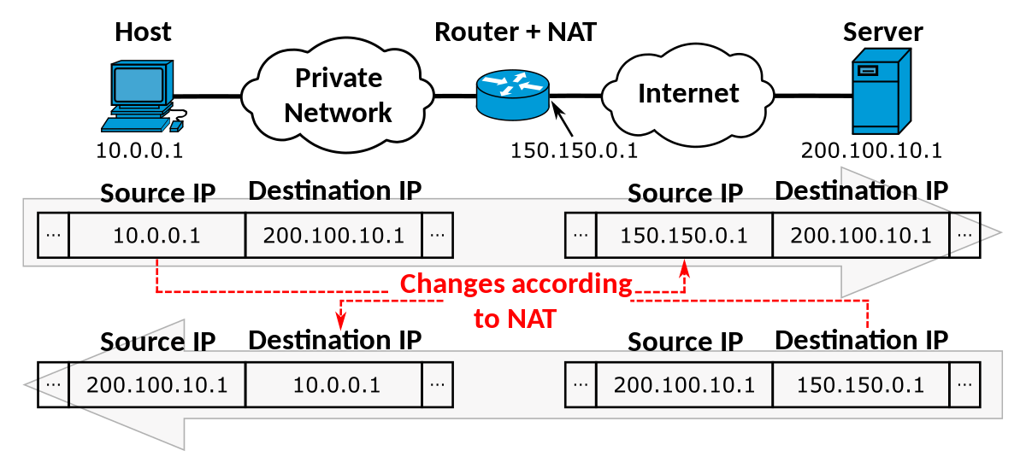
Q6 network monitoring systems :
Systems for monitoring a network's performance, such as traffic volume and bandwidth consumption, are made up of both software and hardware tools. These systems have the ability to recognize machines and other network-connected parts, or they can connect to the network and provide status updates.
Network administrators rely on network monitoring tools to find problems with devices, connections, and failures like traffic bottlenecks that obstruct data flow. Now, sections of the network that were previously outside of their demarcation borders are included in their ability to detect problems. These programs can use network analytics to provide reports and email administrators about issues.
The principal advantages of a network monitoring system are:
1. Be ready for outages at all times:
One of the simplest and most fundamental ways to avoid IT failures is network monitoring. Using network monitoring software, you can find interruptions that could lead to bottlenecks. It gives you the knowledge you need to stay ahead of any problems by presenting up-to-date network performance statistics in an intuitive interface.
2. Quickly fix problems:
Network monitoring software helps you solve problems and move forward. Live network maps direct you to the problem's origin, and status reports show performance trends over time. Network monitoring is able to automatically fix problems in addition to detecting them.
3. Assess security risks:
A network monitoring tool enables your business to provide a fundamental degree of safety. It presents a picture of "normal" performance, making anything unusual easy to notice. By investigating an occurrence to learn when and with what device it occurred, you may actively participate in network security.
TASK C: Security Controls and standards
Q7 Risk assessment and integrated enterprise risk management:
1 . Network change management
With this system/discipline in place organising and maintaining information about all of the components in a computer network becomes significantly easier.
Network device configuration information will be stored in a centrally located server, where device configurations can be easily downloaded.
The network administrator refers to the network configuration management database to determine the best course of action when repairs, modifications or upgrades are needed.
USE INCLUDE :
Daily checking of device configuration data to spot any changes in configuration files, which could reveal cyber threats and potential failures
Creating bulk changes such as implementing mass changes to passwords on devices throughout the network
Auditing and reporting allowing for easy track information about network components.
2 . Audit control
An organisation that is unaware of how and where security breaches might occur could soon be faced with a situation that will be costly, and could be very embarrassing.
Instead, a security audit should be conducted to check what might go wrong, and to plan improvements before a hacker – or some other individual – takes advantage of the situation.

3 . Business continuance/disaster recovery plans
While a security audit will identify weaknesses that ought to be addressed, and an organisation should make every effort to remedy any shortfall, there will always be a risk of a security breach.
For this reason, an analysis of risks should be carried out and a contingency plan drawn up
This contingency plan should cover backup, offsite storage, data recovery procedures, access to immediate hardware replacement, plus insurance that covers replacement, loss of business and all the recovery work.
BACKUPS
Employees who are responsible for data recovery should also know the procedures to follow.
The aim should be to plan ahead so that the whole system can be up and running again within a specified time-scale, e.g. 24 hours.
Then, if the worst case scenario happens, disaster recovery should be as smooth as possible. The contingency plan has to be developed from a full risk analysis, so that every eventuality is taken into consideration.

4 . Potential loss of data/business
Costs
◦ If data is lost, costs are incurred in recovering the data.
◦ If software is corrupted, a copy should be available, but the replacement will take time and incur staff costs.
◦ Depending on how serious a breach was experienced, there may be a need to consult specialists, and this too will incur extra costs

Loss of business
◦ A security breach can result in the collapse of an ICT system.
◦ The time during which normal service is not available is called downtime.
◦ Organizations that rely on an ICT system to take orders will suffer a loss of business during the downtime. Some customers will come back later, but some will not; they will already have taken their business elsewhere.
◦ If a security breach causes data loss, and it proves difficult to recover that data, then the result can be disastrous for an organization.

5 . Intellectual property
Intellectual property protection helps you to stop people stealing or copying:
◦ the names of your products or brands
◦ your inventions
◦ the design or look of your products
◦ things you write, make or produce Copyright, patents, designs and trade marks are all types of intellectual property protection. You get some types of protection automatically, others you have to apply for. Consider that you must have mechanisms in place to protect a company's IP
6 . Hardware and software

7 . Probability of occurrence e.g. disa
1. Define and document the methodology (including the catalogues), distribute it to all asset owners in the organization
2. Organize interviews with all the asset owners during which they should identify their assets, and related vulnerabilities and threats; in the second step ask them to evaluate the likelihood and impact if particular risks should occur
3. Consolidate the data in a single spreadsheet, calculate the risks and indicate which risks are not acceptable
4. For each risk that is not acceptable, choose one or more controls from Annex A of ISO 27001 – calculate what the new level of risk would be after those controls are implemented

This helpful diagram will show you the ISO 27001 Risk Assessment and Treatment process, considering an asset – threat – vulnerability approach. Get an easy overview of the connections
♣ between an asset and related threats and vulnerabilities. See how you can provide a visual interpretation
♣ of the Risk Assessment and Treatment process to facilitate the understanding and participation of everyone in your organization.

ster, theft; staff responsibilities; Data Protection Act; Computer Misuse Act; ISO 31000 standards

integrated risk management as a collection of strategies and practices that, supported by a hazard culture and enabling technology, enhance decision-making through an integrated picture of how an organization manages its particular mix of risks. IRM, to put it simply, is concerned with the risky decisions that businesses make when implementing technology to streamline crucial business processes. For instance, you may have observed servers taking customer orders in restaurants using laptops or phones rather than pencils and paper. The efficiency of front-of-house and back-of-house communications has been improved by the switch to digital information gathering and transmission. However, placing digital devices that could be connected to other systems in the hands of wait staff while they engage with customers has consequences.
Your ability to identify hazards and determine who might be harmed and how will be strengthened by their integration. They'll also teach you how to assess threats and select safety measures, as well as how to record your findings and put them into action.
security issues within organizations Example: Depending on the case, we may have a security vulnerability that is various access points that puts the network at risk because we have online workers and on-site employees talking with other branches. If we are attacked, the hacker will have multiple points of access into the network to assault.
By having a clause that prohibits employees from communicating with other branches and giving online workers access to the network or sensitive data, this example highlights the security inconsistency between its security and the organizational policy. This makes it much simpler for an attacker to hack an online worker's home than a company.
Compatibility is the capacity for two or more entities to coexist or act in harmony without difficulty or conflict, which clarifies its meaning and makes it much easier to understand.
Organizational incompatibility occurs when a policy prohibits something that interferes with security efforts. For instance, if the policy prohibits unauthorized access to company servers or information and there is an emergency or the company has been compromised by a cyber attack and you are unable to handle it, you must hire a third party to act as your cyber-security provider because of the policy.
Q8: data protection

What is Data Protection?
Data protection is the act of preventing crucial data from being corrupted, compromised, or lost and giving the capacity to restore the data to a useable state in the event that something were to happen to make it unavailable or inaccessible.
Data protection ensures that information is not tampered with, is only accessible for permitted uses, and complies with any applicable legal or regulatory requirements. Data that has been protected must be accessible when needed and usable for the intended function.
However, the definition of data protection encompasses more than just the idea of data accessibility and usability; it also includes concepts like data immutability, preservation, and deletion/destruction.
According to the Figure below, traditional data protection (such as backup and restoration copies), data security, and data privacy are three major areas that make up data protection. The methods and tools employed to safeguard data can be viewed as business procedures and data protection mechanisms that help to achieve the overall objective of maintaining the immutability and continuous availability of crucial business data.
We have something called DPA or (Data Protection Act) which Controls how groups, enterprises, or the government use your personal information. The DPA 2018 is the United Kingdom's implementation of the GDPR. They must ensure that the information is used fairly, lawfully, and transparently.
Outlines stringent restrictions known as (data protection principles): and it’s all about that everyone in charge of using personal data must adhere to rigorous guidelines known as (data protection principles):
- When used fairly, lawfully, and transparently
- Used for specific, stated reasons
- Used in an acceptable, relevant, and limited manner to whatever is required
- Correct and, if required, kept up to date
- maintained for no longer than is absolutely necessary
- Handled in a secure manner, includes protection against unauthorized or unlawful processing, destruction, damage, access, or loss

And there is more legal protection for more confidential material, such as race, ethnic background, political ideas, religious beliefs, trade union membership, genetically biometrics (where used for identification), orientation.
Outlines your rights to know what government information and other organizations have on file about you.
These include the right to:
- Understand how your data has been utilized.
- Personal data can be accessed.
- Have inaccurate data updated
- Stop or limit the usage of your data.
- Data portability allows you to have and utilize your data for many services.
Principle of data protection:
The fundamental tenet of data protection is the use of procedures and technology to safeguard and make data accessible at all times.

By using disk, tape, or cloud backup to securely store copies of the data that may be used in the case of data loss or interruption, storage technologies can be used to protect data. In addition to traditional backup, additional software technologies (such as cloning, mirroring, replication, snapshots, modified block tracking, etc.) are adding another layer of data protection. Due to technological improvements, it is now standard practice to offer continuous data protection, which backs up the data anytime a change is made to enable almost immediate recovery.
As businesses frequently shift their backup data to public clouds or clouds managed by outside service providers, cloud backup is also growing in popularity. These backups can be used as a disaster recovery facility in place of on-site disk and tape libraries, or they can be used as supplementary protected copies of data.
The Data Protection Act amended the UK's data protection laws (DPA). The General Data Protection Regulation (GDPR) of the European Union and the Data Protection Act of 1998 are both updated by this national statute.
They guarantee that the data is used in a moral, legal, and transparent manner.

The following guidelines must be followed by anybody who uses personal data:
1. Openly, honestly, and lawfully
2. Applied for jobs with specific objectives.
3. Appropriately applied, pertinent, and only when required
4. Reliable and up to date when required
5. not retained for longer than required
6. Be handled in a manner that guarantees proper security, including safety precautions to prevent unauthorized or illegal processing.
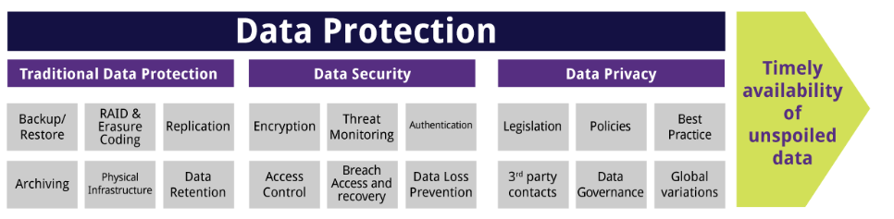
Q9 : STANDARD 31000
According to the ISO 31000 standard, this document is meant for use by professionals who create and preserve value for businesses through risk management, decision-making, setting and achieving goals, and performance improvement.
Because of this, the word "likelihood" in risk management vocabulary is meant to have the same general connotation as the word "probability" has in many languages other than English.
Design identifying the company and its surroundings The company should research and appreciate both its internal and external environments before creating a risk management system.
Implementation The risk management framework should be implemented by the organization by:
- developing an appropriate plan, including time and resources.
- identifying where, when, and how different types of decisions are made across the organization, and by whom.
- modifying the applicable decision-making processes as needed.
- ensuring that the organization's risk management arrangements are clearly understood and practiced.
When properly planned and implemented, the risk management framework will ensure that the risk management process is incorporated into all business operations, including decision-making, and that changes in both internal and external contexts are accurately recorded.
The organization should determine the quantity and type of risk that it may or may not assume when developing risk criteria in connection to the objectives.
While risk management is a practice that all companies engage in to some degree, ISO 31000:2009 outlines eleven guidelines that must be adhered to for risk management to be successful.
There will also be uncertainties surrounding the supporting stages of the risk management process, such as whether the information was delivered correctly while communicating and consulting with stakeholders, or if the intervals selected for monitoring procedures are able to provide sufficient information.
In these situations, professional judgment should be applied along with the relevant information.
What the Principle Looks Like in Practice This strategy involves gathering the opinions of all relevant parties while also recognizing that these opinions could be influenced by social and cultural variables.
In order to maintain the framework's application of these principles of successful risk management, the organization's risk management policy, and its support for the use of the process to make decisions across the organization, it must be monitored and assessed.
Risk management encourages ongoing organizational development.
Q10 SECURITY ADUIT :
A security audit is a systematic review of a company's specific system's security by assessing how well it complies with a predefined set of criteria. A comprehensive audit often evaluates the physical setup and environment of the system, software, information handling procedures, and user habits. A security audit determines if your organization's information system adheres to a set of internal or external data security requirements. Internal criteria include your organization's IT rules and processes, as well as security measures. External criteria include federal regulations such as (HIPAA) and (SOX), as well as standards established by organizations such as (ISO) or (NIST). A security audit compares your organization's current IT practices to enterprise-relevant standards, identifying areas for improvement and development.
And its impact on the organizational security: A security audit will offer a roadmap of your firm's primary information security flaws and indicate where it meets and where it does not match the standards the organization has set out to follow. Security audits are critical for building risk assessment plans and mitigation methods for firms that deal with sensitive and confidential data about persons. A cyber security ,security audit will guarantee that your organization's networks, devices, and data are adequately protected from breaches, and illegal involvement. Security audits are one of three types of cyber security assessment methodologies; the other two are penetration testing and vulnerability assessment, which both include executing real-time tests on the effectiveness of firewalls, malware, passwords, and data security procedures

The security audit in turn identifies the weaknesses that need to be addressed and helps the organization to determine its security status. Once the security audits of the organizations, the results will know whether their security defences are effective against threats such as hackers or not. The report also guides companies further to improve their policies and controls. And its security practices and procedures, and the organization must make all possible efforts to address any shortage that leads to a security breach.

The audits include: -
- review of corporate and technical trust
- Criminal investigation
- Employees check
- Management and review

TASK D Organizational Security Management :

Q11:

What is the policy? A security policy can help an organization identify the crucial assets that need to be protected. This could include the network, physical space, and other assets of the business. Implementing certain personnel policies as well as strong physical and network security are a few possible safeguards. A plan must also be in place for what to do if a threat actually materializes. Alternately, a hacker from outside the system can get access and cause data loss, alter data, or steal data.
What is the CIA triad?
CIA stands for Confidentiality, Integrity, Availability
Confidentiality refers to an organization's attempts to keep material secret or confidential. To combat this, limited data may be classified and labeled, data can be encrypted, and multi-factor authentication methods can be used.
The integrity of the data is only preserved if it's authentic, accurate, and dependable. Hackers may attempt to mess with your company's website in order to harm its reputation or the firm overall.
Organizations can utilize servers, and apps to assure availability. Backups and a thorough disaster recovery plan also assist a corporation in quickly regaining availability following a bad incident. Deliberate attacks, like denial-of-service (DoS) assaults or ransomware, can potentially jeopardize availability.
The CIA triad provides a straightforward yet comprehensive high-level checklist for assessing your security procedures. A successful system meets all three requirements: confidentiality, integrity, and availability. The CIA triad is also useful for determining what went wrong as well as what succeeded following a negative occurrence.
The relation between them? To properly set the policies, we must first check the CIA triad. When we follow the CIA triad, we may work to make both the confidentiality of the information and the integrity of the information and The availability are all at a good level. For instance, when the company creates a policy that improves security in the company, the availability will be diminished. A policy must be set in accordance with the CIA triad when security and accessibility are improved without the information being verified because there is no value to the change because the information is fundamentally false.
The policy must include the following:
1.Authorized staff : This issue-specific policy spells out how and when employees can remotely access company resources.
If we implement such a policy, it will secure the integrity of the data because we restrict the authorization and it will improve the company's secrecy. We may state the policy for Authorized personnel by meaning employee authority.
2.Firewall updates: Based on the information security policies of the company, a firewall policy specifies how firewalls should handle network traffic for particular IP addresses and address ranges, protocols, applications, and content kinds (such as active content). Some type of risk must exist before a firewall policy is created.
A list of the types of traffic that the company needs should be developed through study, and Describe how they must be guarded, including what types of traffic are allowed to pass across firewalls Situations 16 Based on an assessment of threats, vulnerabilities, and other factors, this risk analysis should; vulnerability mitigation strategies in place, as well as the repercussions if systems or data are compromised.
As new attack types or vulnerabilities emerge or as the organization's requirements for network applications change, firewall policy should be regularly updated and maintained and included in the system security plan. The policy should contain detailed instructions on how to handle rule modifications.
Firewalls should typically block all incoming and outgoing traffic that has not been specifically authorized by the firewall policy—traffic that the company does not require. This procedure, commonly referred to as "deny by default," lowers the possibility of an attack and may also lower the amount of data transferred through the organization's networks. Deny by default is a more secure method than allowing all communication that is not expressly disallowed because of the dynamic nature of hosts, networks, protocols, and applications.
This section provides details on what types of traffic should be blocked. Section 4.1 discusses policies for packet filtering and stateful inspection based on IP addresses and other IP characteristics. Section 4.2 covers policies relating to application-specific traffic. Section 4.3 covers access based on user identity, and Section 4.4 describes policies triggered by network activity.
If we have a dynamic IP or DHCP server, whenever an employee's IP changes, the firewall will update its configuration to allow that IP to connect to the network. The firewall also keeps getting better for security purposes so that it can defend the business from any threats that may arise in the future.
3 . remote access : Over the past ten years, quick technical advancements have encouraged a surge in remote work. For instance, sales staff can now connect remotely to their office networks while on client calls and pull up information that may be crucial for completing deals using tablets and other mobile devices. Recent developments have increased the proportion of remote employees to the US workforce by an estimated 42%.
There are a few difficulties that come with working remotely, such as possible network and computer security issues. Guidelines for remote access, as well as other policies, are definitely needed.
For remote users connecting to the network, a remote access policy acts as a guide. It expands the office's network and computer usage policies, such as the password policy. As long as their devices are likewise comply with the rules, it aids in ensuring that only those users who require network access are granted access. When done correctly, it assists in defending the network against potential security risks.
A remote access policy should address every aspect, including the users who can be granted network access from locations other than the office and the kinds of devices that can be used to connect to the network.
Employees are required to sign a written acceptance of the remote access policy. The policy should also have any other documents that are mentioned in it attached. A combination of automatic and manual methods can be used to enforce strict implementation, which is a requirement.

Q12: organizational disaster recovery plan

1 . The ability to return to an acceptable level of operation after a disaster.

2 . Requires a well-thought-out disaster recovery plan.

3 . A comprehensive implementation of the plan.

4 . Frequent testing and updating of the plan.

Disaster recovery is the process used by a company to regain functioning and access to its IT infrastructure following a natural disaster, cyber attack, or even business interruptions brought on by the COVID-19 pandemic. A disaster recovery strategy may include a number of different disaster recovery (DR) techniques. Business continuity has DR as one of its components.

A company's DRP, or disaster recovery plan, is a written document that outlines exactly how to respond to unplanned crises like natural disasters, blackouts, cybercrimes, and other unexpected disruptive events.

The following are the DRP's components:

1. guidelines for how, when, and under what circumstances the recovery plan must be carried out.

2. Basic protection and recovery information is provided for each key piece of equipment.

3. The names and contact information for key organizational executives and crisis management team members.

4. The address or location of off-site backup facilities, as well as the name and contact information for that individual

5. Disks and backup copies are stored here.

6. Names and phone numbers of significant hardware, software, and service providers.

7. The details and documentation of the hardware, software, configuration, and wire infrastructure of the data center, as well as the most recent insurance information.

8. Information about warranties and service agreements is included with model and serial numbers for large items of equipment.

Q13 stakeholders :
Stakeholders are individuals, groups, or organizations who have an interest or concern in a company. Creditors, directors, workers, government, vendors, as well as the community wherein the company's attractions, were formed are all examples of major stakeholders. It's not like all stakeholders are created equal; a company's consumers are entitled to fair business practices but not to the same level of consideration as its employees.
And we have types of the Stake Holders:
- Primary Stakeholders: Typically, internal stakeholders are individuals who have financial transactions with the company, for example, customers, employees, and so on.
- Secondary stakeholders: Typically, outside stakeholders are those who, while not directly involved in financial transactions with the firm, are impacted by or could influence its operations, for example,communities, business support groups, and so on.
- Excluded stakeholders: Those who have no financial influence on the firm, such as youngsters or the general public.

what function do stakeholders play in security audits?
Internal auditors are frequently called in to detect issues after they have happened, when early warnings may have reduced the risk. we have some techniques for including the appropriate stakeholders in our internal audit procedures, based on views from internal auditors who took part in a roundtable discussion with Internal auditors. Since it lacks visibility to general company patterns, internal audit is often not able to bring value to the company. to detect significant risk elements in the organization, we need to incorporate technology. The internal audit team may have access to the information it requires to drive impact throughout the business by unifying data in a single central dashboard. Internal auditing may be a potent tool in hazard management and overall corporate strategy. Although only if it does have the necessary tools and data to assist the audit team in generating insights that will reduce risk and propel the business ahead. Use best-in-class artificial intelligence technologies to automate activities and expedite data collecting and analysis.

Q14 SECURITY IT :

The rules and procedures for all persons accessing and using an organization's IT assets and resources are outlined in an Information Technology (IT) Security Policy. Effective IT Security Policy is a model of the organization's culture, with rules and processes derived from workers' attitudes toward their data and job. As a result, a good IT security policy is a unique document for each business, created from the viewpoints of its employees on risk tolerance, how they view and value their information, and the subsequent availability of that information. As a result, many businesses will find a standard IT security strategy unsuitable since it does not consider how employees utilize and share information inside the company and with the public.

Security disadvantages include:

• Strict rules

• Difficulty of usage for non-technical users

• Limited resources

• Requires constant updating

• Constantly under assault

A policy for an organization is a set of regulations. As the organization policy administrator, you create an organization policy and apply it to organizations, folders, and projects to impose the limits on those resources and their progeny.

The inflexible nature of corporate rules and regulations can make it difficult to execute changes, which is one of the downsides of organizational policies. Business laws are inflexible and binary by nature, resulting in a tight framework for your staff.

Q15: The benefit of the methods used in our regulatory policy for a company is that these methods increase the security and integrity of data using the tools we mention earlier. What I mean is that all of these methods, tools, and policies will improve a company in many ways, so if we apply all of these, security (confidentiality will increase) as well as data health (data integrity) and all of this will show a huge difference and I think without all of this policy we wouldn't be able to Than to continue our work because we will face all the lost data and we will spend a lot of money for security in incorrect information/data, so this is its benefits.
Policies control how an organization functions by providing guidelines, consistency, accountability, efficiency, and clarity. This provides cooperative members with guidelines and ideas to follow.
- Guidance

- Policies outline an organization's goals and give direction on how to attain them.
- Policies define critical operations such as rental arrears collecting and production cost planning.
- Policies also address issues like:
- basic construction guidelines
- pets
- parking
- No smoking is permitted.
- Policies can also give the board guidelines on how to manage issues when they emerge.

- Consistency

Established rules and procedures guarantee that the organization's operations do not vary or worsen over time, even if important board members, contractors, or workers depart.
Consistent policies also assist new board members in rapidly learning how the organization functions and what is anticipated of them as top executives.

- Accountability
When policies and processes are adequately created and regularly followed, an organization may counter any complaints of unfairness or legal infractions that citizens may submit against it.

- Efficiency
Formal, written rules and procedures boost organizational effectiveness by putting everyone on the same page whenever it relates to objectives and challenges.
While businesses may function without documented residential policies and procedures, they are significantly more efficient and productive when they are.

- Clarity
Once everyone is clearly visible on what should be done and how, and who is accountable for completing it, operations run smoothly.

Plagiarism
Plagiarism is a particular form of cheating. Plagiarism must be avoided at all costs and students who break the rules, however innocently, may be penalised. It is your responsibility to ensure that you understand correct referencing practices. As a university level student, you are expected to use appropriate references throughout and keep carefully detailed notes of all your sources of materialsfor material you have used in your work, including any material downloaded from the Internet.Please consult the relevant unit lecturer or your course tutor if you need any further advice.
Student Declaration
Student declaration
I certify that the assignment submission is entirely my own work and I fully understand the consequences of plagiarism. I understand that making a false declaration is a form of malpractice.

Student signature: Adel Shurab Date:15/9/2022

